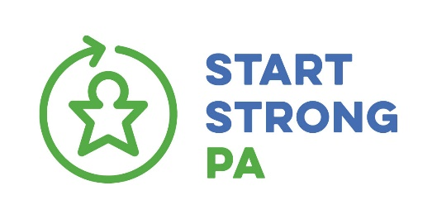
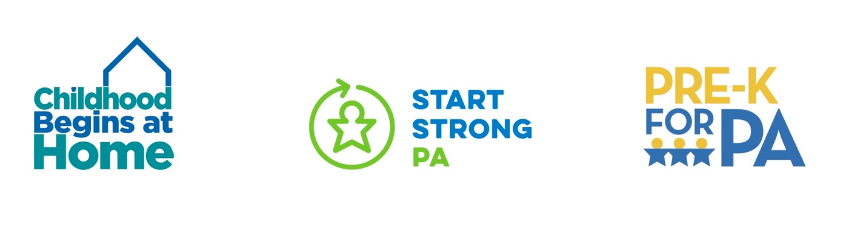FOR IMMEDIATE RELEASE:
CONTACTS:

Carolyn Myers (Childhood Begins at Home) Jodi Askins (Start Strong PA) Kate Phillips (Pre-K for PA) cmyers@papartnerships.org JodiAskins@gmail.com philips@parkerphilips.com
717-756-8992 (mobile) 272-444-1860 (mobile) 215-850-4647 (mobile)

Pennsylvania’s Working Families Need Greater Investment in Early Learning Services
2021-22 State budget: modest growth for pre-k; ignores recommendations prioritizing child care and fails to expand evidence-based home visiting services.

HARRISBURG, PA (June 25, 2021) – The principal partners of Early Learning Pennsylvania (ELPA), a statewide coalition of advocates focused on supporting young Pennsylvanians from birth to age five, believe our economic recovery hinges helping Pennsylvania’s working families by prioritizing greater state investments in high-quality pre-k, child care and evidence-based home visiting services. ELPA operates three issue-based advocacy campaigns: Pre-K for PA, Start Strong PA, and Childhood Begins at Home. Reaction statements from these respective campaigns regarding the 2021-2022 PA state budget.

PRE-K

“The General Assembly deserves to be acknowledged for understanding the importance of expanding access to publicly-funded, high-quality pre-k in PA. We applaud the $25 million in new state funding for Pre-k Counts and $5 million for Head Start State Supplemental as part of the 2021-22 PA State Budget. These funds will provide the once-in-a-lifetime opportunity of high-quality pre-k to more than 3,000 young learners.

“Research shows that high-quality pre-k benefits children's cognitive, social and emotional development. Unfortunately, prior to the pandemic, only 44 percent of eligible children in Pennsylvania are currently enrolled in publicly-funded, high-quality pre-k.. That means 56 percent of eligible children do not have access to this vital early education opportunity due to limited state funding. We must do better, faster, if we are to move the needle on these dismal statistics. Children only have these opportunities once in life, there is no do-over.

CHILD CARE

“Start Strong PA is disappointed that the General Assembly did not include language prioritizing our American Rescue Plan child care funding fast track recommendations. These recommendations were developed with input from over 1,000 child care providers and parents, and were designed to help Pennsylvania’s working families find and afford high-quality child care.

“Given that 70 percent of Pennsylvania children under the age of five had all adults in their household in the labor force prior to the pandemic, high-quality child care is an essential workforce support. That workforce must be able to return to work for Pennsylvania to recover from the pandemic’s economic devastation.

“We now call on Governor Wolf’s Administration prioritize and implement our recommendations for Pennsylvania’s $1.2 billion in American Rescue Plan child care funding. With nearly 700 child care programs permanently closed and over 350 temporarily closed, families are struggling to find child care. Those child care providers that have managed to stay open are still incurring additional pandemic related costs while operating significantly under capacity.

“Not only is there less child care capacity in the system, fewer than half of that certified child care capacity currently meets high-quality standards. And only 34 percent of infants and toddlers that receive subsidized care attend programs that have met high-quality standards. High-quality care and education mean safer, healthier children and are critical to maximizing the period of a child’s most rapid brain growth.

“Start Strong PA American Rescue Plan child care funding recommendations will stabilize, strengthen and ultimately secure the child care industry. This industry is critical to the success of our economic recovery.

EVIDENCE-BASED HOME VISITING

Missed opportunity
Failed to continue the momentum

“From birth to age 5 brain growth is rapid, learning is happening, and our coalition of advocates is committed to ensuring that families can access it in high-quality, developmentally appropriate settings. In Pennsylvania, the resources are just not there to offer these irreplaceable opportunities, creating deep inequity among children and their families at a very early age. We, and our tens of thousands of supporters, will continue to urge lawmakers to boldly invest in early learning – it is an urgent necessity.”

#####

